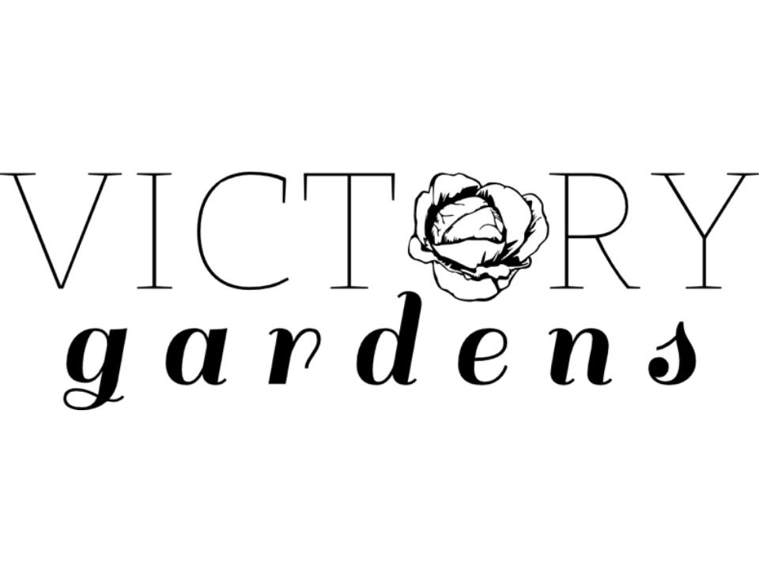
Crafting Ecological and Abundant Spaces for Coastal Georgia

APPLICATION FOR EMPLOYMENT
Please fill out the application in its entirety and attach a resume.
Email application/resume to savannahvictorygardens@gmail.com

Date: _____________ Position you are applying for: _________________________

When are you available to work? ________________________________________
Do you have a valid driver's license? ______________________________________
Full Name:___________________________________________________________
Address:_____________________________________________________________
City:______________________________ State:_______ Zip:__________________
Phone:____________________ Email: ____________________________________

Education
Highest Level of Education:__________________ Date Acquired:______________
School:______________________________________________________________
Degree/Certifications Earned: ___________________________________________

Current/Previous Employment
Company:___________________________ Phone:__________________________
Address:_____________________________________________________________
Job Title:_____________________ Hourly rate/Salary (Start/End)______________
Dates Employed From:__________________ To:___________________________

What do you know about Victory Gardens?_________________________________ ________________________________________________________________________________________________________________________________________
What is the best job you ever had? Why? __________________________________
________________________________________________________________________________________________________________________________________
____________________________________________________________________
Do you have a garden or landscaped area where you live? What do you enjoy most about that space?______________________________________________________
____________________________________________________________________________________________________________________________________________________________________________________________________________
Please list any relevant experience to the position you are applying for (i.e. gardening, hardscapes, construction, sales, customer service, receptionist, accounts payable/receivable)
________________________________________________________________________________________________________________________________________________________________________________________________________________________________________________________________________________________________________________________________________________________________________________________________________________________________________________________________________________________________________________________________________________________________

Applicant’s Statement
I certify that answers given herein are true and complete to the best of my knowledge. I authorize investigation of all statements contained in this for employment decision. I understand that this application is not intended to be a contract of employment. In the event of employment, I understand that false or misleading information given in my application or interview will result in discharge. I understand that I am required to abide by the rules and regulations of the Company.

Signature of Applicant_____________________________ Date _______________

